DAY1

ClassDiagram(Gym Trainer & Progress Tracker Application):
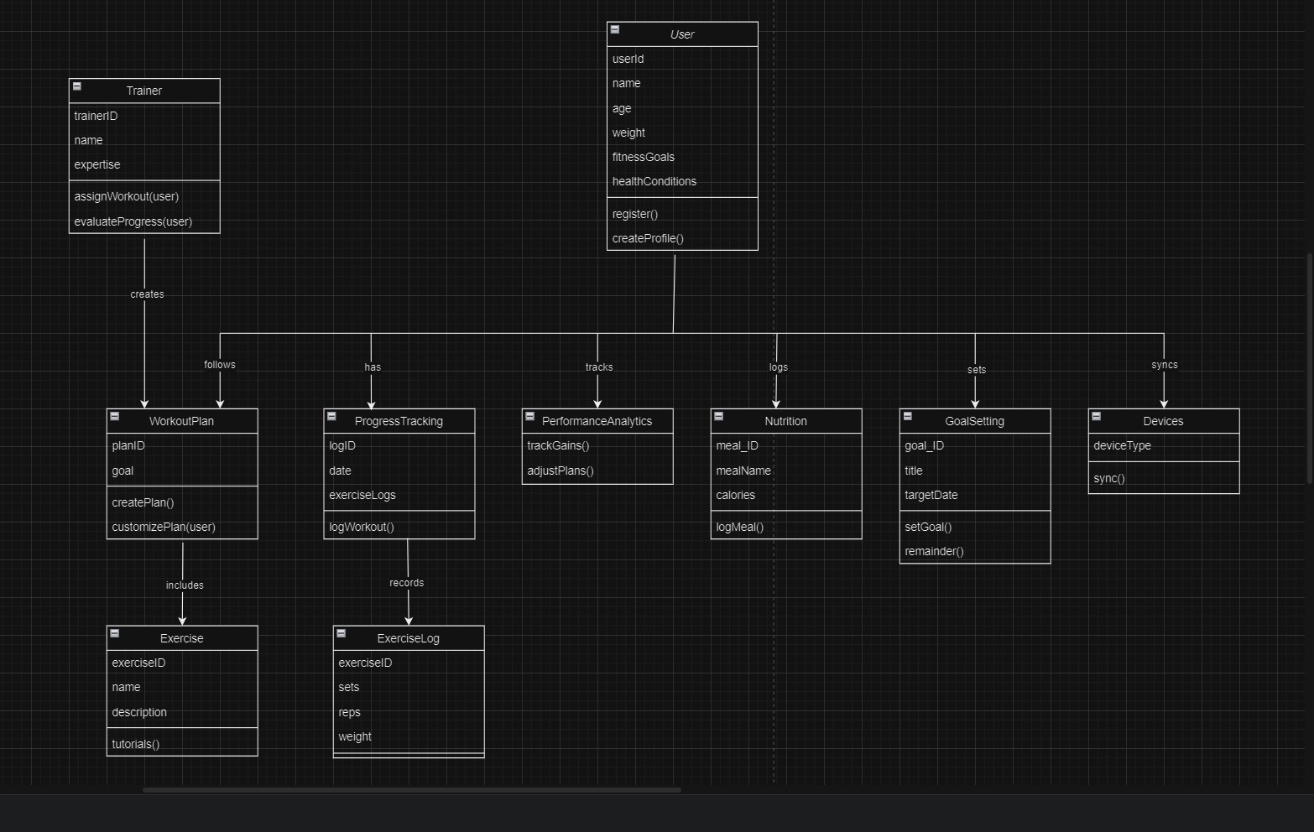

ER Diagram:
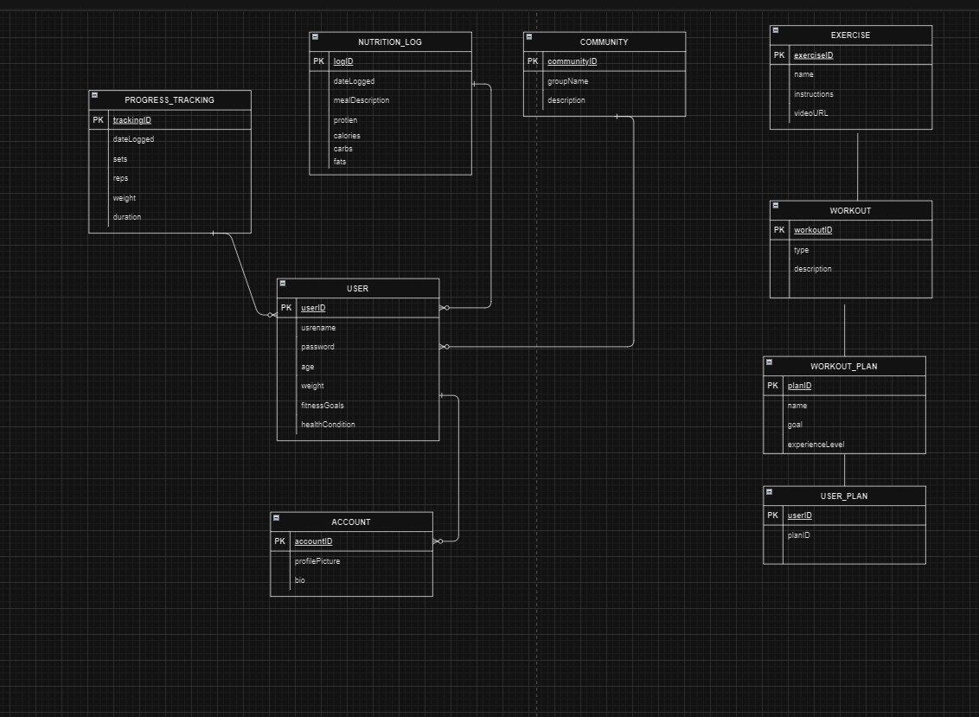

Sequence Diagram:
